

Mateusz Zaboklicki 40212780 | Advanced Web Technologies | November 30, 2016

Remember It Application

**Python Application Report**

Contents

1. Overview 2

Users Implications 3

Design implications: 3

Resources: 4

2. Software Design 4

3. Evaluation of the application 5

3.1 Unforeseen Events. 5

3.2 Weak and Strong Points of the project. 5

4. Screenshots 5

5. References 10

# Overview

For my second course work I was asked by Dr. Simon Wells to create online application that should be designed with Python software and running in Levinux environment. The application should be also available to access through Putty. The application should include other languages like CSS, HTML, JavaScript however the main language used for this project should be Python programing.

This time I decided to develop an application that will be also easy to interact and to navigate by other users. I decided that my target audience will be every single person that is over 18 years old and would like to discover live stories of people that survived World War 2. Application was originally designed and developed for training and learning purposes and in the future I would like to develop bit further when I’m going to feel more comfortable and confident while using Python programing.

My application is available to access through my GitHub account: <https://github.com/mati87118/MZaboklicki-Coursework-2>

“Remember It” is an online application that allow users to get more knowledge about World War 2 and the concentration camps. I decided to implement interview that I recorded with my grandmother some time ago. In this interview my grandmother is telling the story of her life and the times that her and her mother were captured by Nazis and placed in Dachau concentration camp. In the application, I also placed the page with the stories of other people that either survived the war or were kept in concentration camp. I also place decided to implement the Dachau page where the users will view where the cam is placed and they will be able to access so additional information about cam along with few extra pictures. Your story section is a page where users can login using appropriate credentials and share their story with other users. The story that users will share will be then stored in database and will appear on the post page. I decided to use SQLite for my databases because it is easy to use and that is something different from the JSON that I was using in my last coursework.

The purpose of application that I developed was to share the history of the people that survived the WW2 or concentration camps. I decided that is important to remember those horrible times and all people should remember what one person can do to the other one in the name beliefs or color of skin of other people. Another purpose of that application was to present my programing skills and the experience that I gained during the time that I was working through tutorials and workbook.

### Users Implications

During the time that users will use my application there are some tasks that they can perform like:

* Read information about “Remember It” application that can be accessed on the “Home” and “Dachau” page.
* Watch the interview with the person that survived the concentration camp.
* Access actual map of Dachau concentration camp and some pictures.
* Share their stories with other users by using your story page.
* Users can access my online application using most popular internet browsers at the localhost address <http://localhost:5000>
* User will be redirected to the <https://www.kz-gedenkstaette-dachau.de/index-e.html> page where there accesses the direct information about concentration camp.

### Design implications:

* Consistent navigation – Navigation will be easy to use and will be consistent through the all pages of my application. Navigation will be placed on the top of the page too provide professional look and to avoid any confusion.
* Content - that will be used in my application will be clear and easy to access.
* Fonts – that will be used in the application will be user friendly, easy to read and visually attractive.
* Color scheme and layout – both stay consistent across whole application to provide as professional look as possible and to be suitable and attractive for users.

### Resources:

To complete the project successfully I was using mostly module workbook that was provided by Dr. Simon Wells. I was also accessing necessary notes that can be accessed on module website. Very helpful for this coursework was knowledge of the students that were helping us during the practical session in JKCC. I was also accessing the pages like Stack Overflow where I founded a lot of support from other users, I also accesses documentation that was provided Python official website. On the top of that I was watching many tutorials and using even international forums that can be found in reference section. All the pictures that I used in my application comes from my family albums. The interview that appears on the website was also recorded by me.

# Software Design

Application development stage was the most challenging part of the second coursework even though I had some previous experience while working with Python in my previous assignment. Lack of experience appeared to be the biggest problem however I took some steps to improve my lack of this knowledge. As I had some of the experience with the previous project I once again used the workbook that was provided by Dr. Simon Wells. Then I reviewed all the tutorials that were provided on the module website. Both workbook and tutorials were very helpful and helped me to sort some of the problems. I spent many hours on watching tutorials on YouTube where experienced users were taking me step by step through the necessary tutorials. Lynda.com once again appeared to be very helpful and because I was using it previously in my previous project it helped me a lot.

I already had installed my laptop all necessary software and environment that I wanted to my application run on. I also decided to use Bootstrap templates that were provided by Dr. Simon Wells and were available on module website. It seems to be the best and the easiest option for my application to run smoothly which saved me from confusion and frustration. I followed all the steps that were in module workbook to customize my application.

The problem that appeared in previous project and once again was driving me crazy was while I was message printed in Putty “broken pipe” and because of that it was necessary to restart the application repeatedly. I was once ageing going through all the moments of frustration like in my previous project.

Another problem that arose was the SQLlite where I decided to design my database however once again Stack Overflow and YouTube appeared to be the most helpful places to seek for the help and advice. After completing few tutorials, I founded the solutions on how to install the SQLite and how to design the database and how to connect it with my application.

# Evaluation of the application

If I would be able to once again in the future do the same project I would like to add more functionality to my application like creating the register form where all users can register and because of that they would be able to share their stories with the rest of the users.

I would like to also add admin panel which would add more functionality to my application. It would be very helpful for administrator to delete or edit some of the stories from the database.

I would have spent more time on improving my HTML to make it looks more professional and user friendly.

The biggest problem while I was working on my application was lack of necessary experience which caused a frustration while working on my application. However, with every single minute that I spent on developing my application I felt more confident.

I can say that I that I learnt a lot about Python programing but there is a long way on the front of me to improving my skills and knowledge.

### 3.1 Unforeseen Events.

During the time that I was working on my second coursework the same unforeseen event appeared like in my previous project and because of that I haven’t that much time that I was expecting. The problem was the health issues of my wife that had IVF treatment and during that times she was taking still some chromones which caused a lot problems and once again I had no other option but either go with my wife to the hospital or stay at home and take care over her.

### 3.2 Weak and Strong Points of the project.

Time management is a weak point and the area where I should improve in the future. Health problems of my wife once again affected my time manage badly. I was also not expecting that additional research will take me so long and because of that I won’t have a enough time to work on my report.

Strong point of the project was the access to all necessary resources like Python, Putty, VIM, WIN SCP and Microsoft Word which were very helpful. The workbook provided by Dr. Simon Wells were also a strong point of the project because it allowed me to successfully complete my project.

# Screenshots

Home Page

# 

Dachau Page

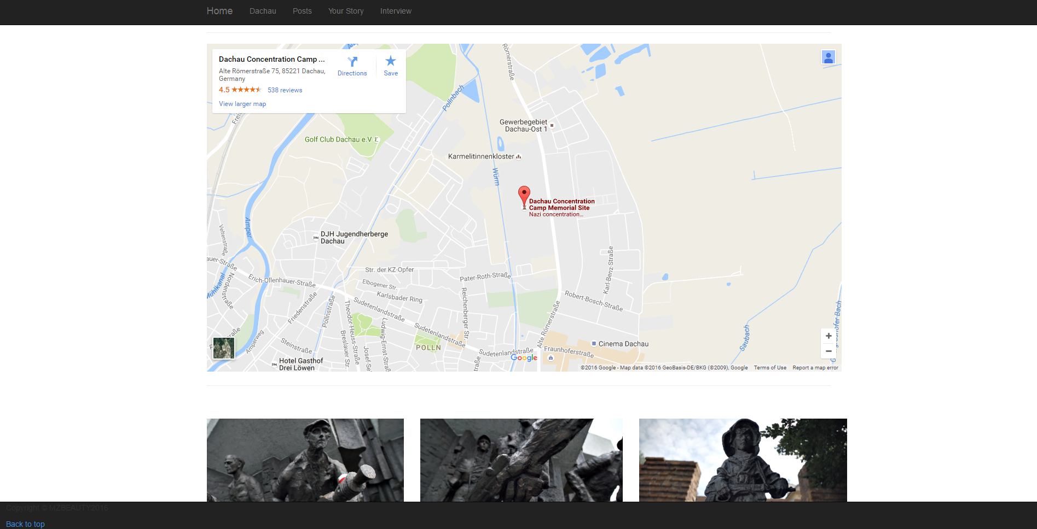

Posts Page

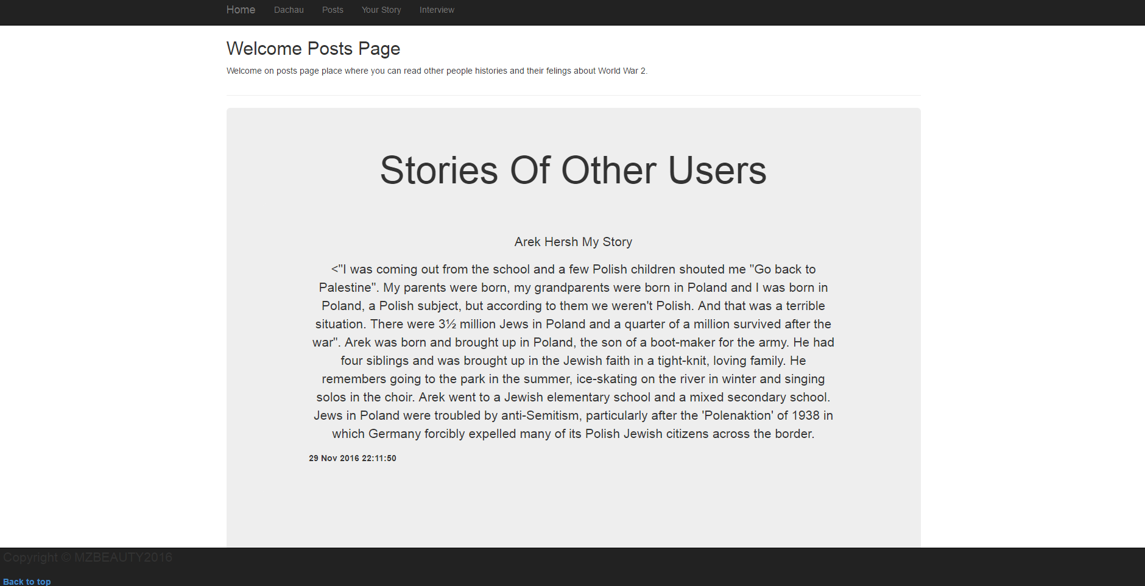

Your Story Page

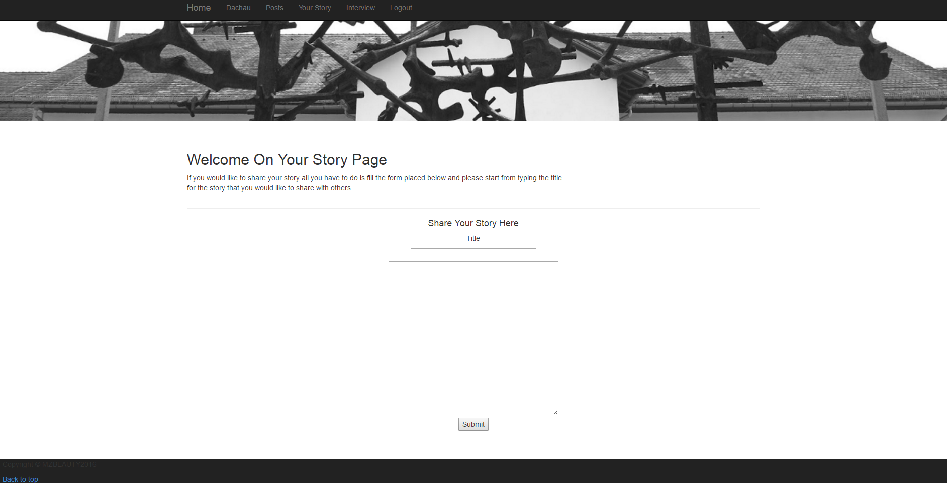

Interview Page

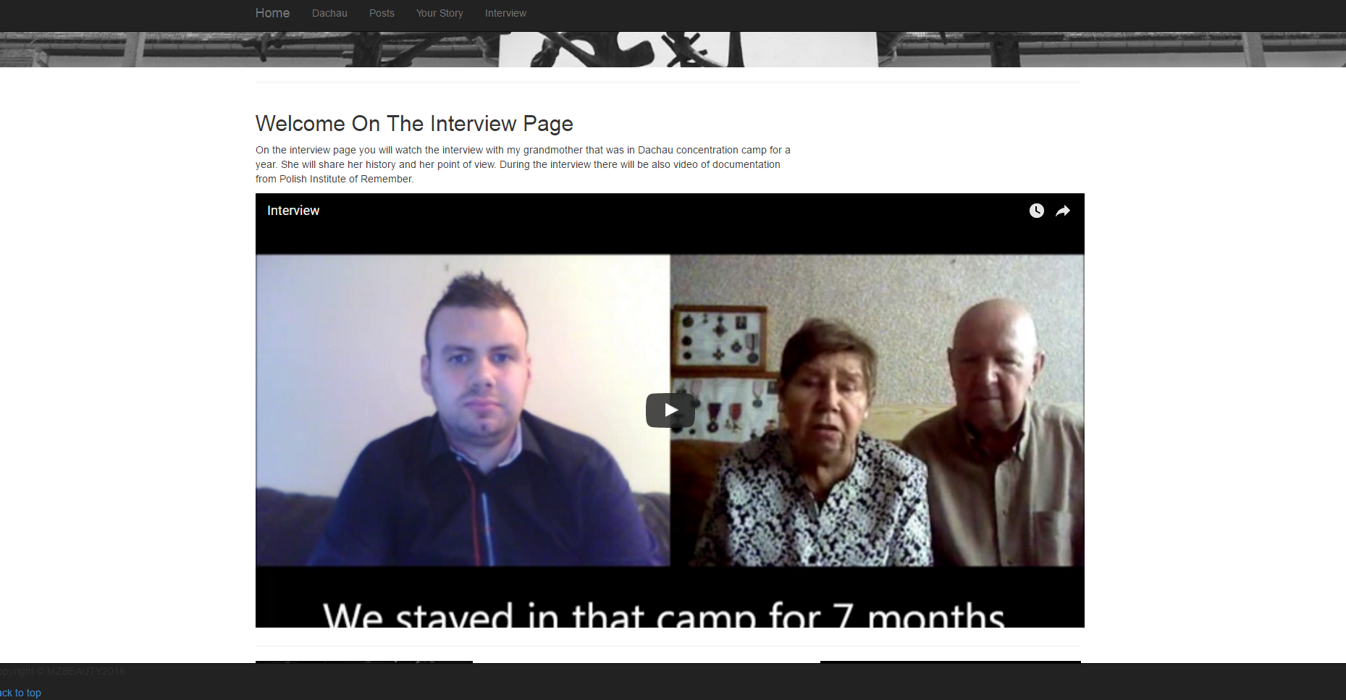

Login Page

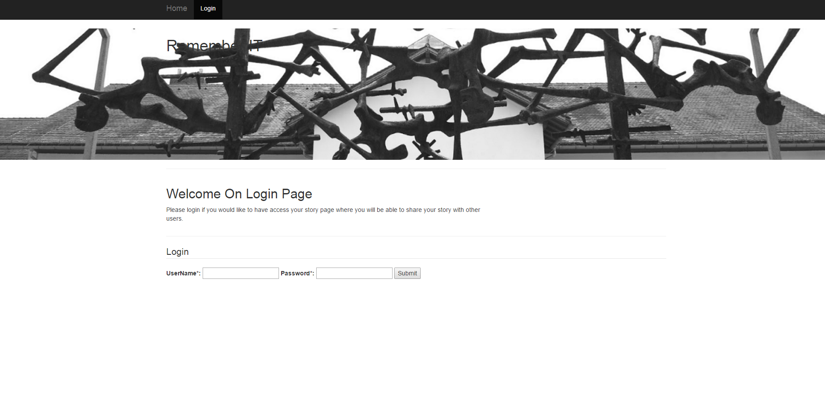

Redirecting to Dachau Website After Clicking on “Read More”

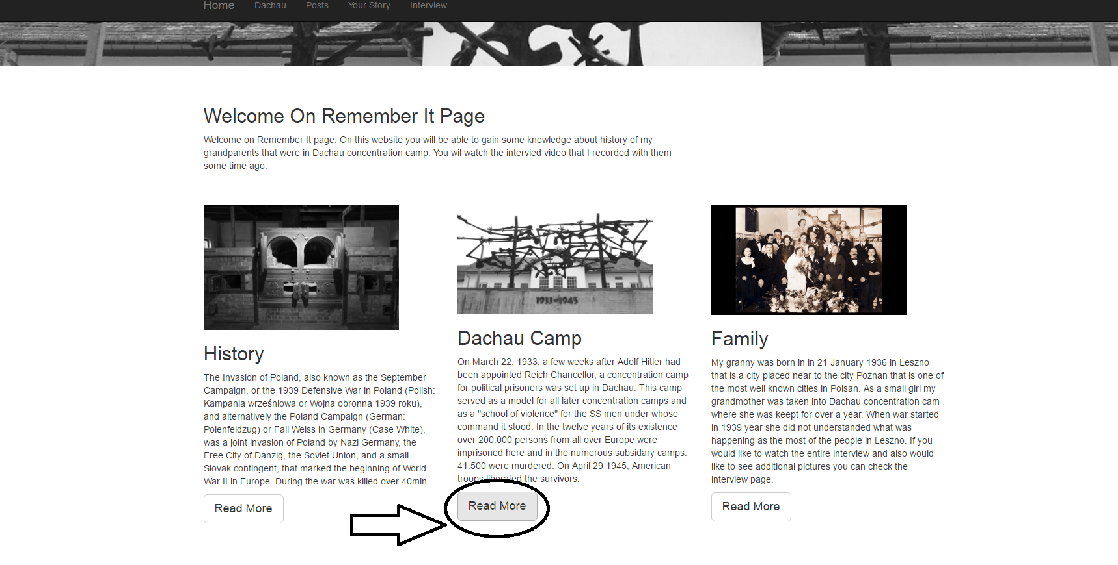

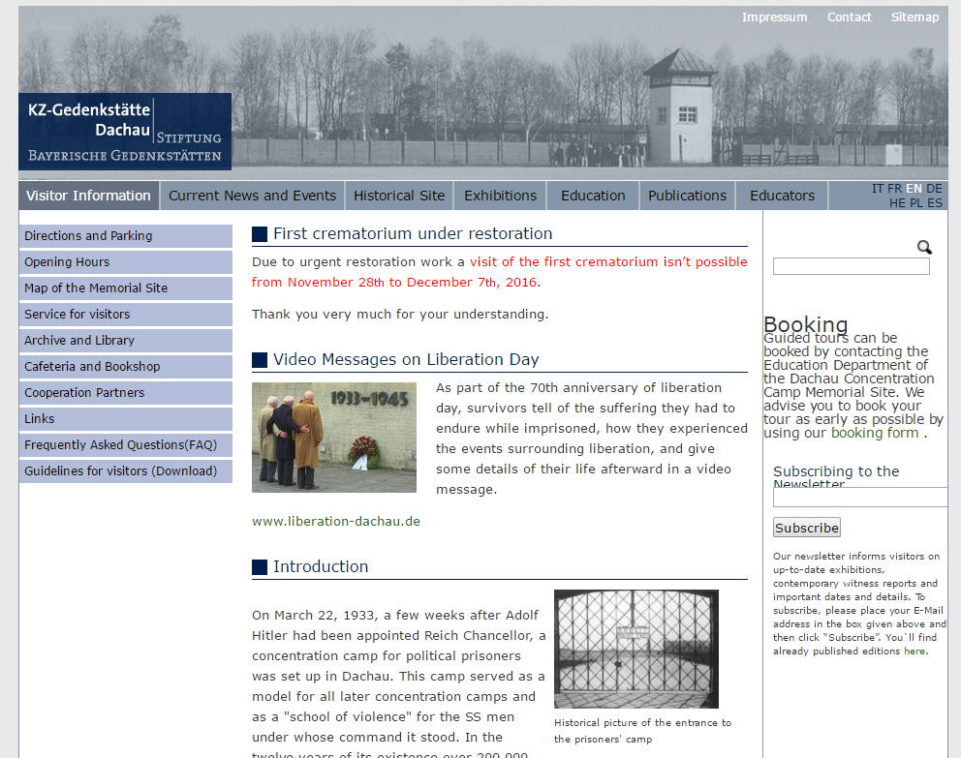

GitHub Repository (https://github.com/mati87118/MZaboklicki-Coursework-2)

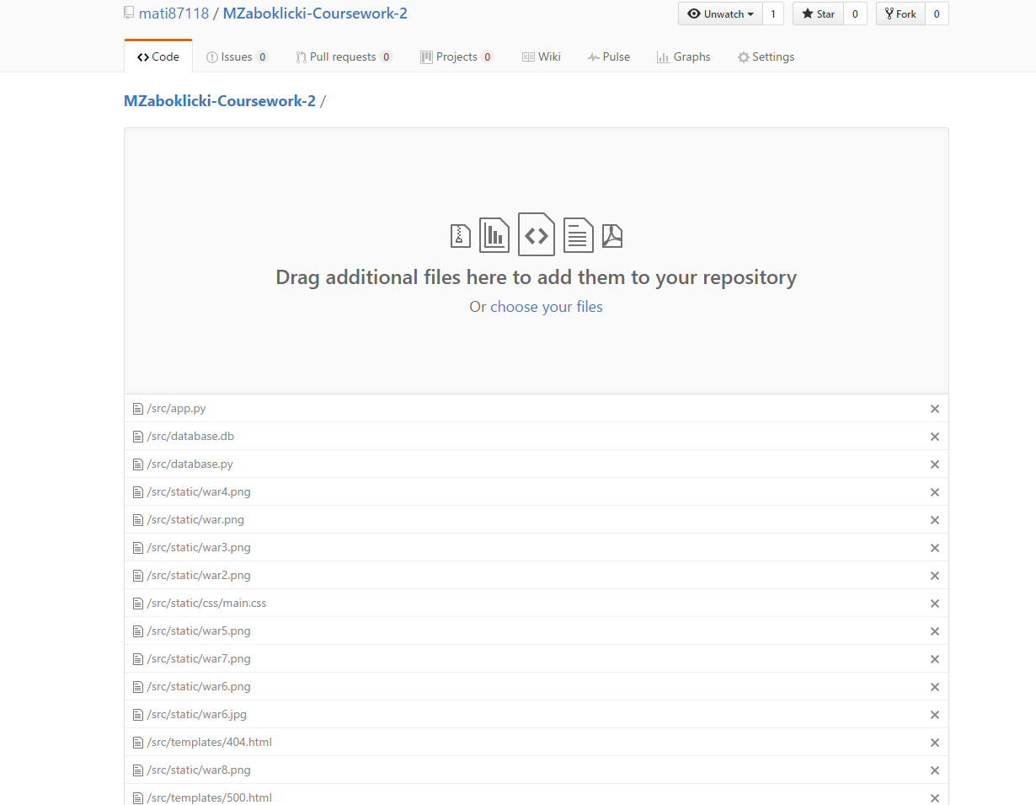

# References

* ***Course source code, Accessed 06 November***

*https://github.com/siwells/teaching_set09103*

* ***Advanced Technologies Module website, Accessed 06 November***

*http://siwells.github.io/teaching_set09103/*

* ***Flask Web Development with Python Tutorial – 1 -Basic App, Accessed 08 November 2016***

*https://www.youtube.com/watch?v=ZVGwqnjOKjk&list=PL6gx4Cwl9DGDi9F_slcQK7knjtO8TUvUs*

* ***Flask Tutorial Web Development with Python part 1 – 35, Accessed 08 - 13 November*** *https://www.youtube.com/watch?v=Lv1fv-HmkQo&list=PLQVvvaa0QuDc_owjTbIY4rbgXOFkUYOUB*
* ***Flask Tutorial Web Development with Python Tutorial – 1 – 7, Accessed 08 November 2016***

*https://www.youtube.com/watch?v=ZVGwqnjOKjk&list=PL6gx4Cwl9DGDi9F_slcQK7knjtO8TUvUs*

* ***SQLite databases, Accessed 12 November 2016***

*https://www.lynda.com/Flask-tutorials/Learning-Flask/521231-2.html*

* ***SQLite Python Tutorial, Accessed 13 November 2016***

*http://zetcode.com/db/sqlitepythontutorial/*

* ***SQLite Python Tutorial, Accessed 13 November 2016***

*https://www.tutorialspoint.com/sqlite/sqlite_python.htm*

* ***Python 2.7 tutorial pt 1-12 SQLite, Accessed 18 November 2016***

*https://www.youtube.com/playlist?list=PLGLfVvz_LVvTsslWD1HBQEjBbmAaAF9Xy7*

* ***Python Requests tutorials 1 - 4, Accessed 22 November 2016***

*https://www.youtube.com/playlist?list=PLei96ZX_m9sXRb1mVw21fahHDufSvJTLe*

* ***SQLite Python Tutorial, Accessed 22 November 2016***

*http://stackoverflow.com/questions/1185406/how-do-i-start-a-session-in-a-python-web-application*